1-Syllable

🔤 What is a Syllable?
# Source: Chatgpt (GPT-4-turbo) at [7/24/2025]
A syllable is a basic unit of sound in a word. It usually contains one vowel sound, and it may also include surrounding consonants. Words are made up of one or more syllables.

📘 Definition:
# Source: Chatgpt (GPT-4-turbo) at [7/24/2025]
A syllable is a unit of pronunciation that has one vowel sound, with or without surrounding consonants, and forms a whole beat in a word.

🧠 Key Features of a Syllable:
# Source: Chatgpt (GPT-4-turbo) at [7/24/2025]
- Has one vowel sound (not necessarily one vowel letter)
- May have consonants before or after the vowel
- Sounds like one “beat” when spoken

🔍 Examples:
# Source: Chatgpt (GPT-4-turbo) at [7/24/2025]
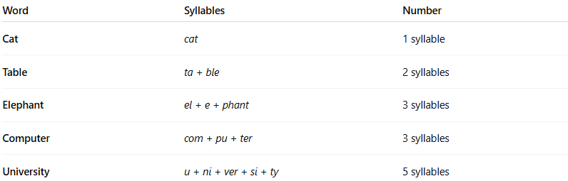

Word | Syllables | Number
Cat | cat | 1 syllable
Table | ta + ble | 2 syllables
Elephant | el + e + phant | 3 syllables
Computer | com + pu + ter | 3 syllables
University | u + ni + ver + si + ty | 5 syllables

👂 How to Count Syllables:
# Source: Chatgpt (GPT-4-turbo) at [7/24/2025]
- Speak the word slowly and clap for each beat you hear.
- Count how many distinct vowel sounds (not letters) are in the word.

✅ Summary:
# Source: Chatgpt (GPT-4-turbo) at [7/24/2025]
A syllable is a unit of sound in a word, typically made up of one vowel sound with optional consonants.
It's what gives a word its rhythm or beat in speech.

2-Syllabogram

🧩 What is a Syllabogram?
# Source: Chatgpt (GPT-4-turbo) at [7/24/2025]
A syllabogram is a written symbol that represents a syllable — typically a consonant-vowel (CV) combination or just a vowel or consonant.
It is a key part of syllabic writing systems, where each symbol stands for one syllable of sound rather than a single phoneme (like in alphabets) or a whole word (like in logographic systems).

📘 Definition:
# Source: Chatgpt (GPT-4-turbo) at [7/24/2025]
A syllabogram is a grapheme (written symbol) that represents one spoken syllable in a language.

🔍 Examples of Syllabograms:

1. Japanese Kana (Hiragana & Katakana):
# Source: Chatgpt (GPT-4-turbo) at [7/24/2025]
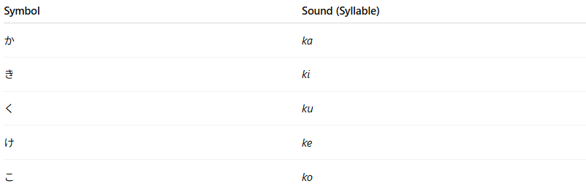
Symbol | Sound (Syllable)
か | ka
き | ki
く | ku
け | ke
こ | ko
Each of these characters is a syllabogram — they stand for a full syllable, not just a letter.

2. Linear B (Ancient Greek):
# Source: Chatgpt (GPT-4-turbo) at [7/24/2025]
- An early syllabic script used to write Mycenaean Greek.
- Example: A single symbol could stand for pa, to, ke, etc.

3. Cherokee Syllabary:
# Source: Chatgpt (GPT-4-turbo) at [7/24/2025]
A script invented by Sequoyah to write the Cherokee language.
Example:

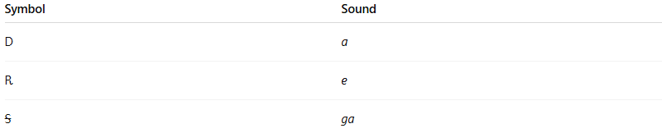
Symbol | Sound
Ꭰ | a
Ꭱ | e
Ꭶ | ga

🧠 Syllabogram vs. Other Units:
# Source: Chatgpt (GPT-4-turbo) at [7/24/2025]
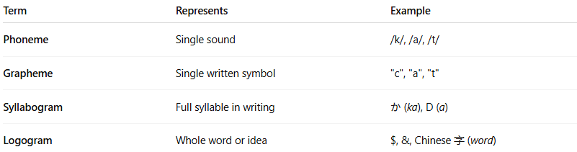
Term | Represents | Example
Phoneme | Single sound | /k/, /a/, /t/
Grapheme | Single written symbol | "c", "a", "t"
Syllabogram | Full syllable in writing | か (ka), Ꭰ (a)
Logogram | Whole word or idea | $, &, Chinese 字 (word)

✅ Summary:
# Source: Chatgpt (GPT-4-turbo) at [7/24/2025]
A syllabogram is a written character that represents a whole syllable rather than a single sound or a whole word.
It's found in syllabic scripts like Japanese kana, Cherokee, and Linear B.

3-Logogram

🔣 What is a Logogram?
# Source: Chatgpt (GPT-4-turbo) at [7/24/2025]
A logogram is a written character or symbol that represents a whole word or meaning, not just a sound like in alphabets or syllabaries.

📘 Definition:
# Source: Chatgpt (GPT-4-turbo) at [7/24/2025]
A logogram is a written sign that stands for an entire word or morpheme, rather than representing the individual sounds (phonemes or syllables) that make up the word.

🧠 Key Idea:
# Source: Chatgpt (GPT-4-turbo) at [7/24/2025]
- One symbol = one word or concept
- It represents meaning, not just sound

🔍 Examples of Logograms:

✅ Chinese Characters (Hanzi):
# Source: Chatgpt (GPT-4-turbo) at [7/24/2025]
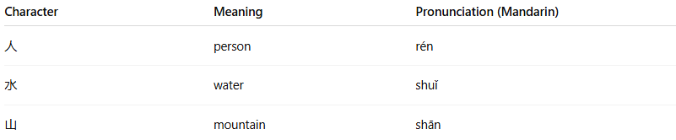

Character | Meaning | Pronunciation (Mandarin)
人 | person | rén
水 | water | shuǐ
山 | mountain | shān
Each symbol represents a full word or morpheme — these are logograms.

✅ Ancient Egyptian Hieroglyphs:
# Source: Chatgpt (GPT-4-turbo) at [7/24/2025]
Some glyphs stood for entire words or ideas (like “sun” 🌞 or “king”).

✅ Sumerian Cuneiform:
# Source: Chatgpt (GPT-4-turbo) at [7/24/2025]
Early logograms used in Mesopotamia (e.g., a picture of a fish representing the word “fish”).

✅ Modern Symbols (sometimes):
# Source: Chatgpt (GPT-4-turbo) at [7/24/2025]
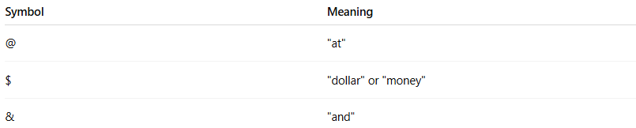

Symbol | Meaning
@ | "at"
$ | "dollar" or "money"
& | "and"
These are not part of a logographic writing system, but they function as logograms because they stand for whole words.

🧬 Logogram vs Other Writing Symbols:
# Source: Chatgpt (GPT-4-turbo) at [7/24/2025]
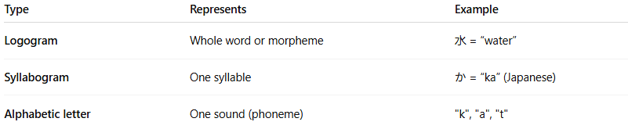
Type | Represents | Example
Logogram | Whole word or morpheme | 水 = “water”
Syllabogram | One syllable | か = “ka” (Japanese)
Alphabetic letter | One sound (phoneme) | "k", "a", "t"

✅ Summary:
# Source: Chatgpt (GPT-4-turbo) at [7/24/2025]
A logogram is a symbol that represents a whole word or idea, used in logographic writing systems like Chinese, Sumerian cuneiform, and parts of Egyptian hieroglyphs.

4-Mora

🕰️ What is a Mora?
# Source: Chatgpt (GPT-4-turbo) at [7/24/2025]
A mora is a unit of sound timing in phonology that helps determine the rhythm or length of a syllable.
It is especially important in languages where syllable weight affects pronunciation, stress, or poetry — like Japanese, Latin, and Ancient Greek.

📘 Definition:
# Source: Chatgpt (GPT-4-turbo) at [7/24/2025]
A mora (plural: morae or moras) is a unit of metrical time that determines the duration or weight of a syllable in spoken language.

🧠 Basic Concept:
# Source: Chatgpt (GPT-4-turbo) at [7/24/2025]
- A short syllable has one mora
- A long syllable has two morae
- In some cases, extra-long syllables may have three morae

🔍 Examples by Language:

🇯🇵 Japanese (very mora-based):
# Source: Chatgpt (GPT-4-turbo) at [7/24/2025]
Japanese counts morae more than syllables.
- Nippon (Japan) = にっぽん → 4 morae:
  - に (ni) = 1 mora
  - っ (glottal stop, small tsu) = 1 mora
  - ぽ (po) = 1 mora
  - ん (n) = 1 mora
Even though it's 2 syllables, it has 4 morae.

🇬🇷 Classical Latin & Greek (for poetry):
# Source: Chatgpt (GPT-4-turbo) at [7/24/2025]
- A vowel like "a" is 1 mora
- A long vowel or a vowel followed by a consonant cluster = 2 morae

🧬 Mora vs Syllable:
# Source: Chatgpt (GPT-4-turbo) at [7/24/2025]
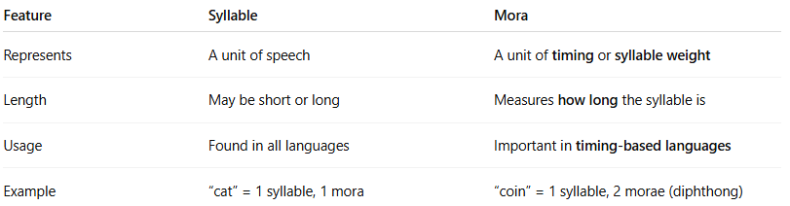

Feature | Syllable | Mora
Represents | A unit of speech | A unit of timing or syllable weight
Length | May be short or long | Measures how long the syllable is
Usage | Found in all languages | Important in timing-based languages
Example | “cat” = 1 syllable, 1 mora | “coin” = 1 syllable, 2 morae (diphthong)

✅ Summary:
# Source: Chatgpt (GPT-4-turbo) at [7/24/2025]
A mora is a small unit of time or rhythm in speech. It's used to measure how long a syllable lasts, especially in poetic meter or language rhythm.

